Employment User guide for Head Office
When you log in – under the employment module you will have various sub modules:
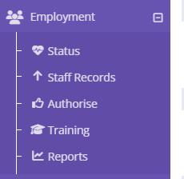
Status:
This gives you a snapshot view of employment across the business:
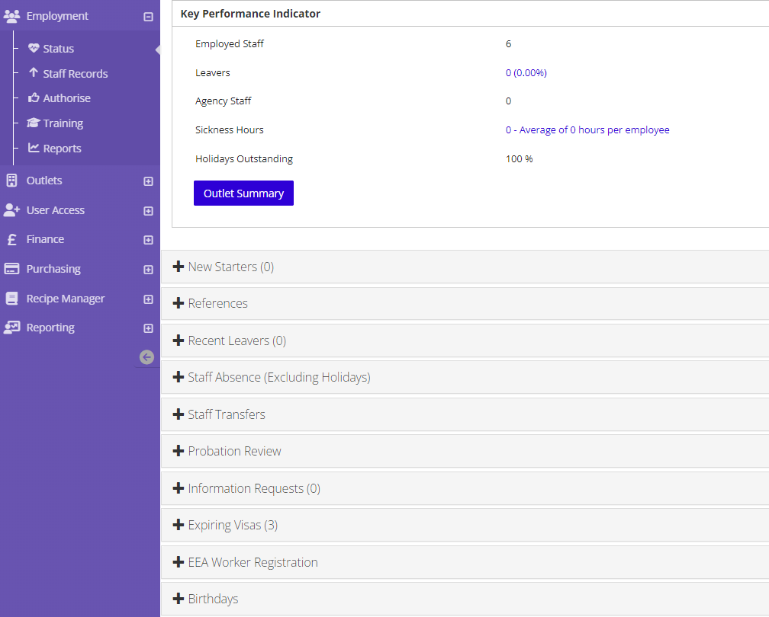
For example probation reviews due:
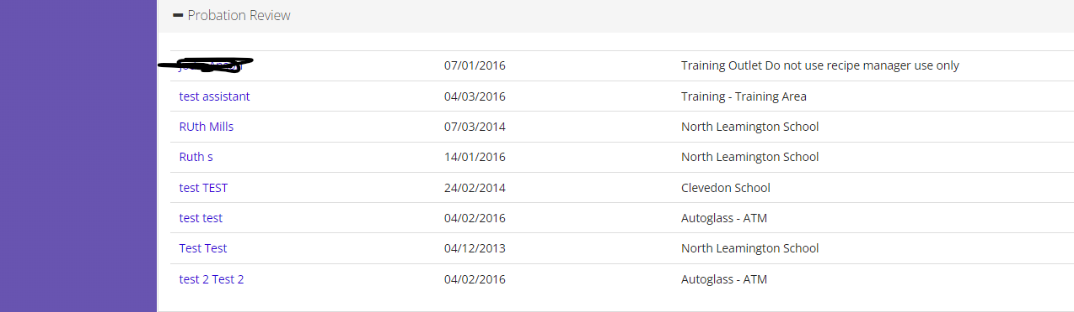
Staff Records:
This enables you to store HR information about employees - record documents such as copies of passport, the actions area will allow you to upload appraisals, you can also check employees training.
The personal and Employment tabs can be amended by HO once the outlet creates the initial employee record
Authorise:
This is where you will approve staff records that have been created within the outlet:
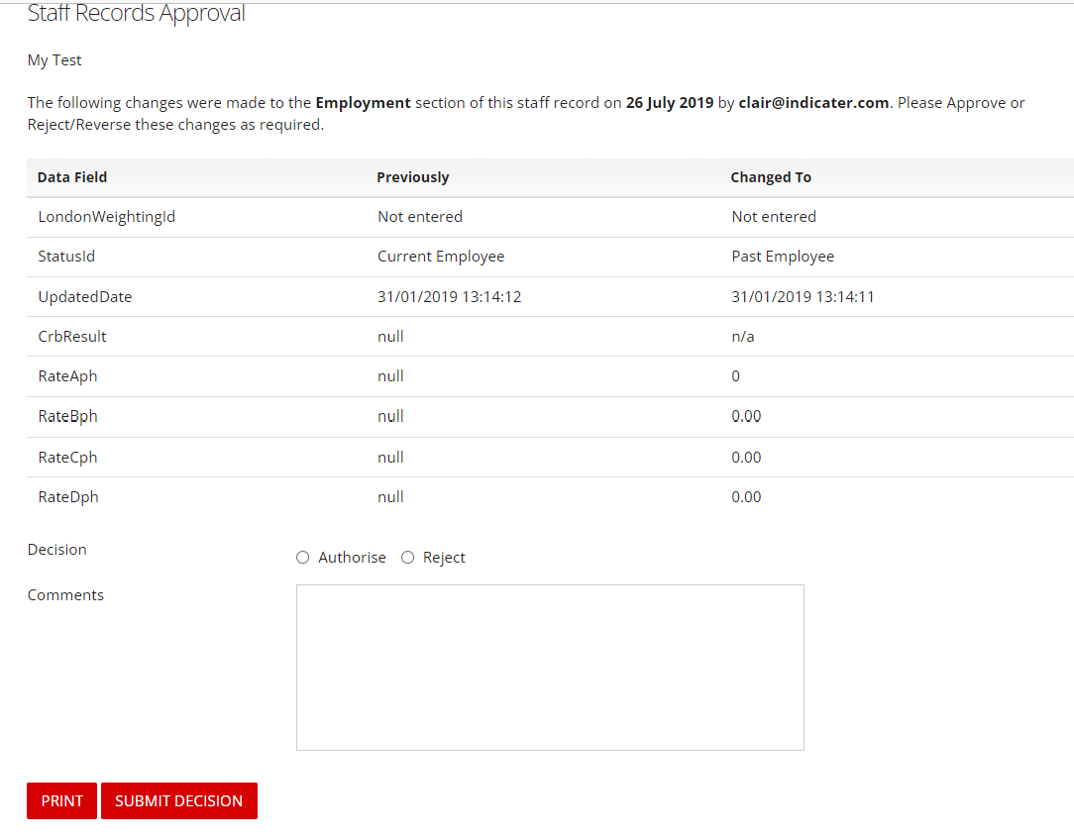
And approve any holiday requests:
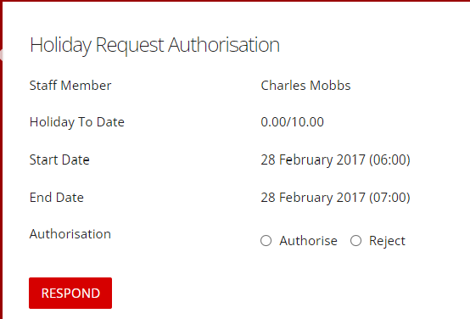

Headlines:
You can add employment headlines some examples below and these will show on the Today page so users will see when they log in:
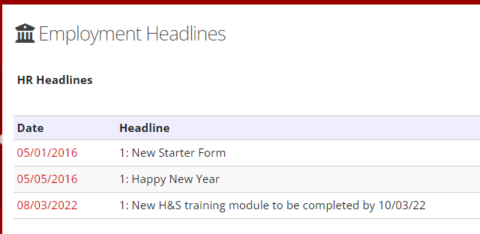
Today page:
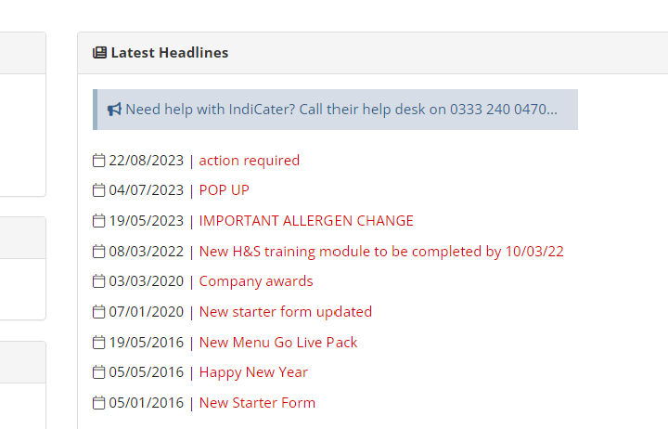

Training:
Training Programmes and Training modules can also be added
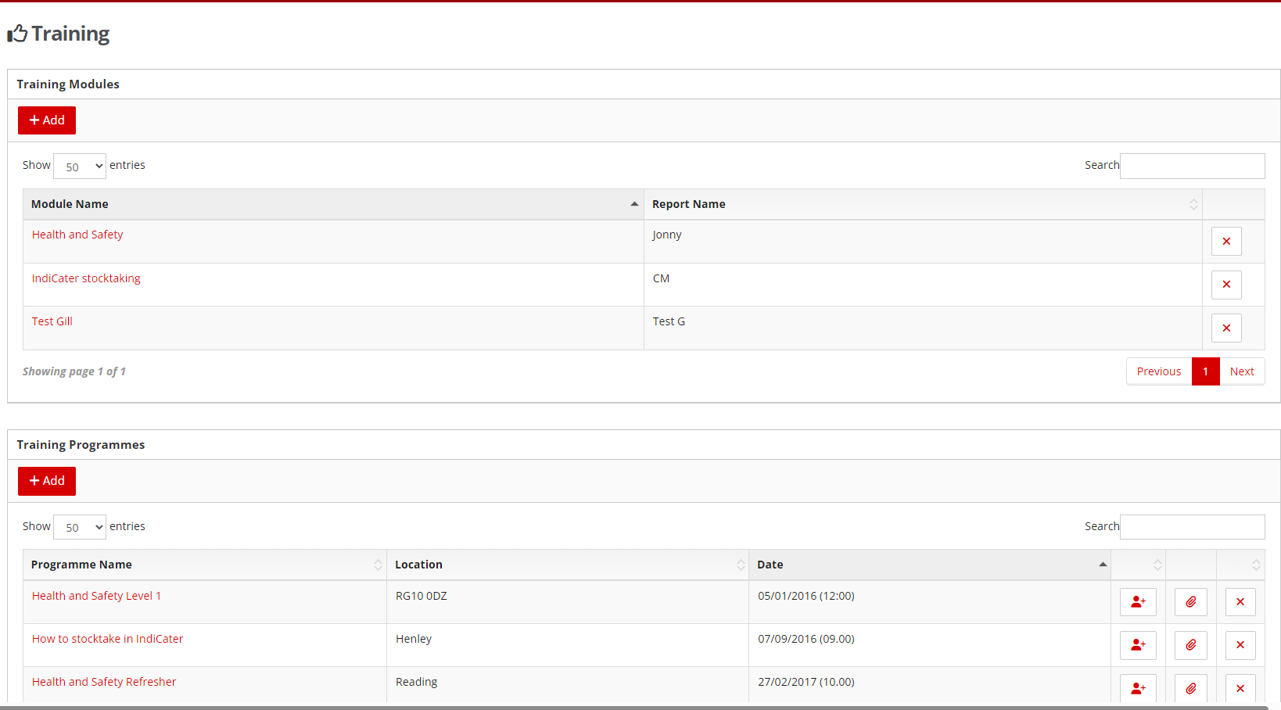
Reports:
From HO you can run various reports, timesheets for all outlets or one outlet, staff absence, training overdue, staff sickness pay rates, these are just a few.
If you wish to report on other HR data that is input in the system and you can’t find a report, please let IndiCater support know.
Staff rota timesheets can also be run using the new Employment report which is an excel document, this is found by going into Company>reports>new reports>Employment report

