USING THE EMPLOYMENT MODULE BY OUTLET MANAGERS

The Employment module should be used to record your staff daily shift hours on rota in advance and then at the end of each day to make any changes based on the actual hours worked and record any hours an employee is absent.
At the end of each week, you should run the Timesheet report and check it is correct, then close your Employment week to confirm you are happy that this report correctly reflects all the hours worked and any absence taken.
How to add a new employee, set up staff record and rota.
When a new employee is recruited you should create a new staff record.
Staff records is accessed by logging into Indicater select employment>staff records>click on the add button and you will then see the following this will add your new employee, once a new employee is added it may need to go to head office for approval (if head office have requested approval levels) before you can complete the full staff record: -
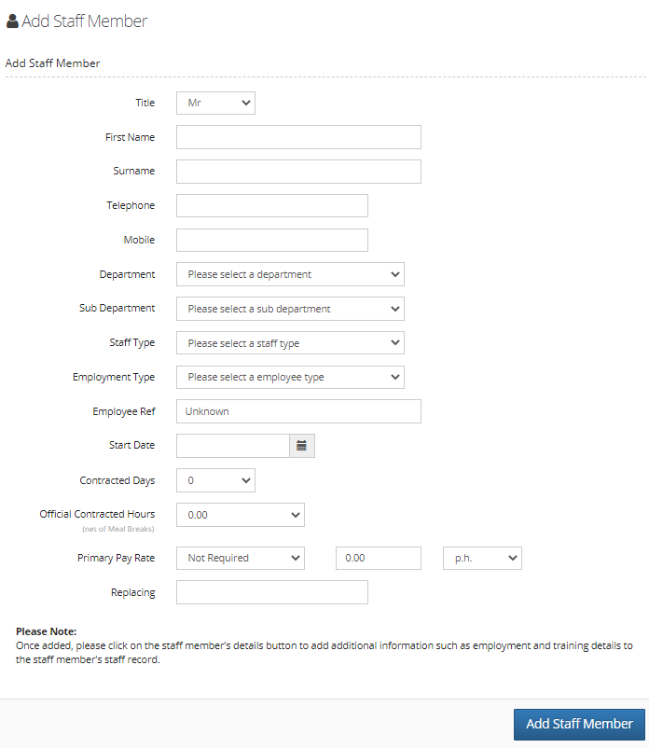

For Employee Type select:
- Full Time/fixed for staff with contracted hours of a minimum of 37.5 hours
- Part Time: for staff with contracted hours less than 37.5 hours but with holiday allowance
- Casual/zero hours for Staff with no set hours
Enter the employee number in the Employee Ref field. Leave the Contracted Days and Official Contracted Hours as zero for casual staff.
Then select ADD STAFF MEMBER which will create a Staff Record.
Next step, once you have added the staff member, (and this has been approved by head office if required approval) you can then go on to complete the rest of the staff record using the personal tab and employment tabs below: -
PERSONAL TAB: complete all fields under General, Next of Kin and Contact Information headings
EMPLOYMENT TAB: The important extra fields to complete are-
Contract Type: Salaried, variable or Zero hours (please advise us if you would like to add any other contract types)
Annual Days Holiday: This is used to record the actual days holiday allowance for those staff with contracted hours. For Casual/Zero Hours staff ‘0’ days should be entered.
NB – you can complete as much or as little data as you want to fit in with your business requirements.
Using the rota: -
ADDING FORECAST SHIFT HOURS TO THE ROTA
To set up the shift hours before pulling them through to the rota go into Employment>staff records>search staff name>click on employment tab > complete the section on the right-hand side as follows: -
Job Description & Pay Rates
A-. For Pay rate A: Select the main Job Description next to A and then enter either their monthly salary (annual divided by 12) and PM, or hourly rate PH etc
B-. You can use pay rate B, C & D for any other pay rates that an employee may have such as different job roles or for overtime.
If an employee is only paid for the hours they work (normally referred to as Zero Hours Contracts) their Job Title should be selected, and their basic hourly rate enter in Rate A.
If you feel the correct Job Description or Premium Rate is not listed in the drop down, then please contact head office for guidance.

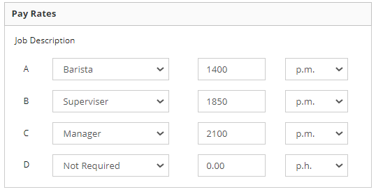

Contract Hours Configuration
Select DAILY HOURS if an employee has set/fixed ‘from’ and ‘to’ hours each day. This is used to save time when populating the rota – ‘Set to default’ will be displayed underneath that person’s name on the rota; if selected it will then populate the Daily Hours from the staff record onto each day of the rota (where they can be changed if required).
Under daily contracted hours you can place a tick for the days off that a fixed hours person usually has eg someone working Mon- Fri would have Saturday and Sunday ticked as days off.
Under contracted hours you can populate the daily fixed hours worked which will then pull through to the rota when you click set to default.

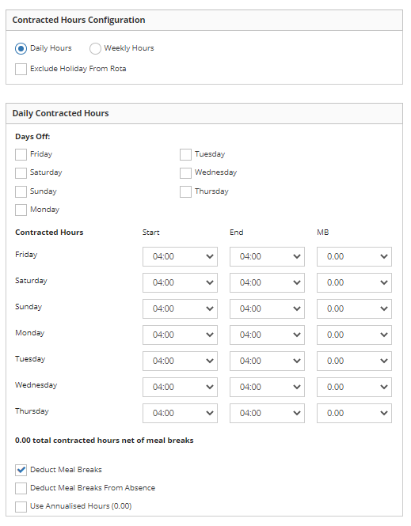

NOTE: The Meal Break drop down to the right of the daily hours is ONLY used to display the normal meal break on the rota view – it does not influence any calculations. Please see separate meal break deductions section below
For Casual employees, then zero Contract Days, zero Weekly Hours and zero Official Contracted Hours must be selected.
The correct number of Official Contracted Hours must be selected for all Full Time and Part Time employees. This is the total contracted hours less meal breaks.

Meal Break Deductions
If the employee has a contract that requires the meal break criteria to be deducted from their rostered hours, in their staff record the following two boxes must BOTH be ticked:
- Deduct Meal Breaks
- Deduct Meal Breaks from Absence
The correct number of Official Contracted Hours must be selected for all Full Time and Part Time employees. This is the total contracted hours less meal breaks.

Annualised hours – this is used for employees if they are any company employees that work less than 52 weeks per year . This must be ticked at the same time that you tick the deduct meal breaks box and the deduct meal breaks from absence box, the third box is called annualised hours, place a tick in this.

The Rota: -
To set your weeks rota up in advance, select Employment>Staff Rota (this will default to ‘today’) and there you can either:
Select ‘Set to Default’ below each employee’s name on the rota and this will populate their default shifts that you have set up in each person’s Staff Record in the Employment tab.
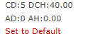
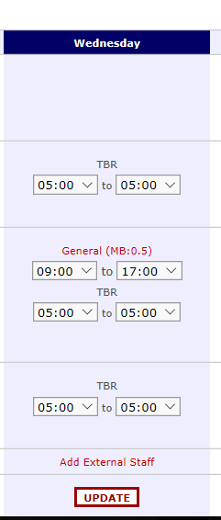
Always select UPDATE at the bottom on each day’s column whenever changes are made
The Shift Name defaults to the department name. This can be edited in the rota for a specific shift (though that will not change future shifts created which will continue to default to the department name – you can change the Department Name in the Set-Up tool in employment)
All shifts will default to be paid at pay rate A for that week, To be paid for a different shift from a different pay rate you need to add in the hours worked in addition to the normal shift in the rota and click on update at the bottom: -
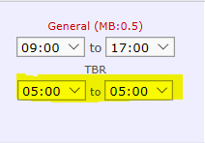
Once you have clicked on update, this shift will allow you to change the pay rate as the TBR header will change and turn red, you will notice it will now say General and be in red.
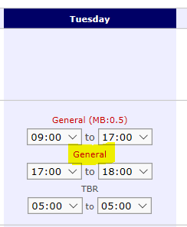
You can now amend that shift to pick up a different pay rate, click on the red General, you will now see a dropdown for job title, your contracted shift that you set up in the employment record will be defaulted at the first job title, the additional hours/pay rate you want to allocate will now be allowed to be chosen from the dropdown (see below) if you choose the extra hours rate, these extra hours will be paid at this pay rate for that shift between 17:00 and 18:00.
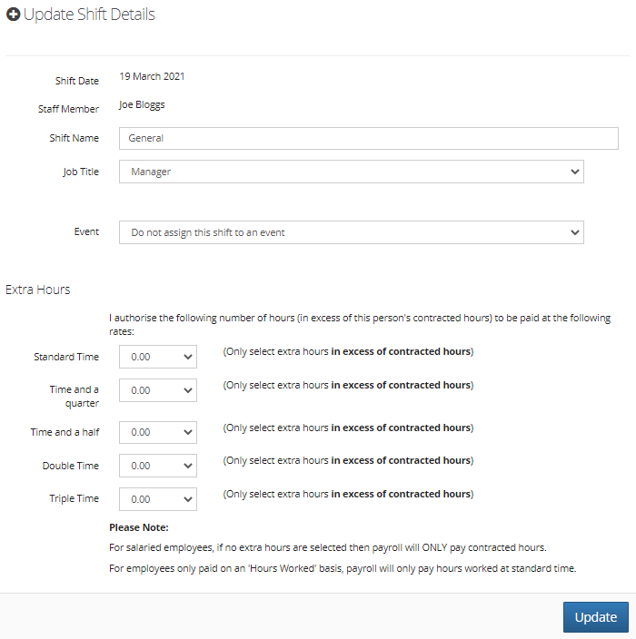

Adding unpaid Sickness/unpaid absence: -
If any person has been off sick for part of a day, or absent for any other reason, then as well as reducing their hours as above also select Add Daily Absence at the bottom of that day’s column.
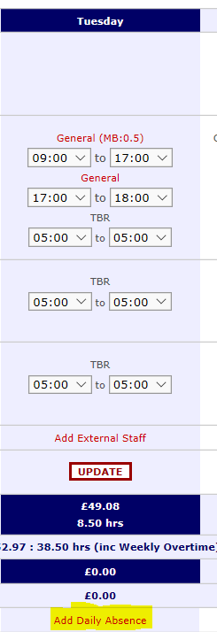
(this option will only appear once you have selected the day) and select the person’s name, the relevant Reason Type, and the number of hours they were absent for (and the correct Absence and Form Types) then ADD ABSENCE. This will display an absence shift above the shift hours they did work. You can also add notes if you wish.

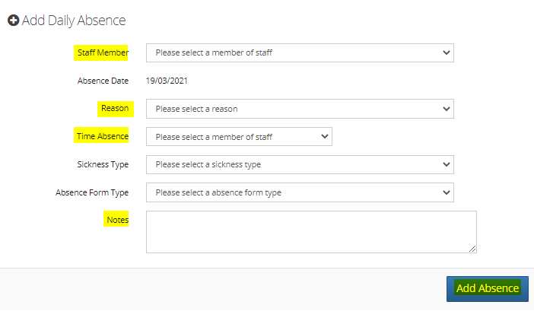
Once you have added the part day absence, you will see the rota change to this: -
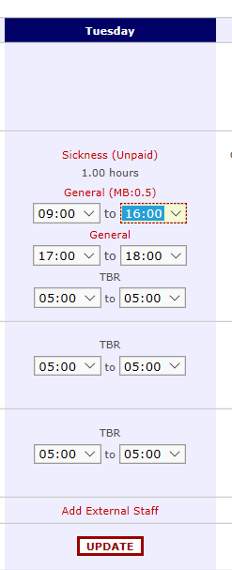
You will note above that you had to reduce the normal shift by one-hour e.g., 9 -4 as opposed to 9-5 and then in the add daily absence you will have selected 1 hr unpaid sickness or 1 hr other unpaid absence.
If an employee is absent for the whole day, still follow the Add Absence process above but then click on their work shift.
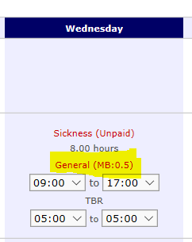
and then select REMOVE FROM SHIFT. If a person is on long term absence (say Maternity Leave) then you can use the Add Weekly Absence option at the bottom of the rota for any full week of absence. (see 2nd screenshot below)
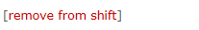
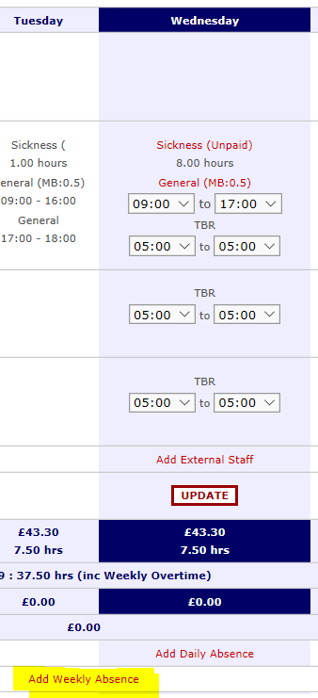
Use the Add Extra Payment option (if you have exhausted all 4 pay rates boxes on the staff record) for any authorised additional payment and complete the Comments box in this option for any other information you need to share about this employee.
When an employee leaves :-
To record an employee leaving, in employment>staff records>search for employee name>click on employment tab>scroll down on the left until you reach the Leaving information tab and record the leaving date
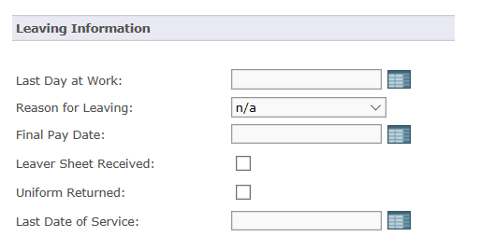

If you need to transfer staff between outlets then you can do this in the transfers icon.
Staff can request holiday in the outlet and this can then be approved by HO (if approvals are required by HO)
Holiday:
To request holiday please click on the holiday module
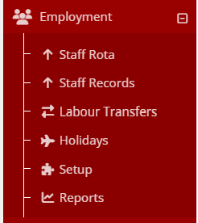
And then once in click on add:
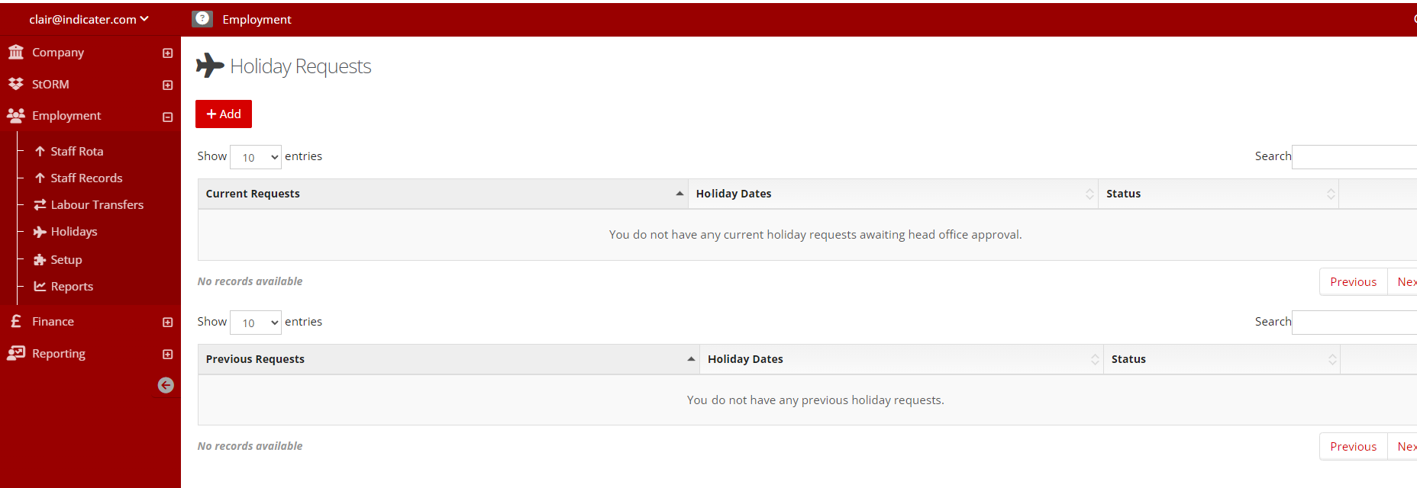
Enter the request and how many days you require the holiday for click send:
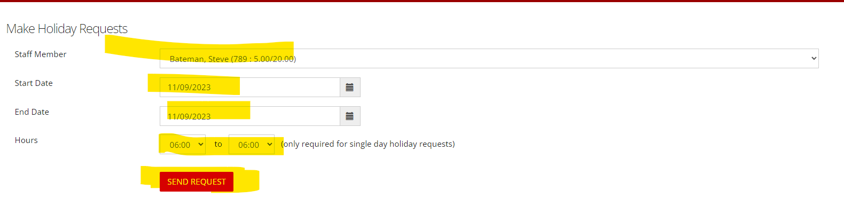
Then once happy click ok:
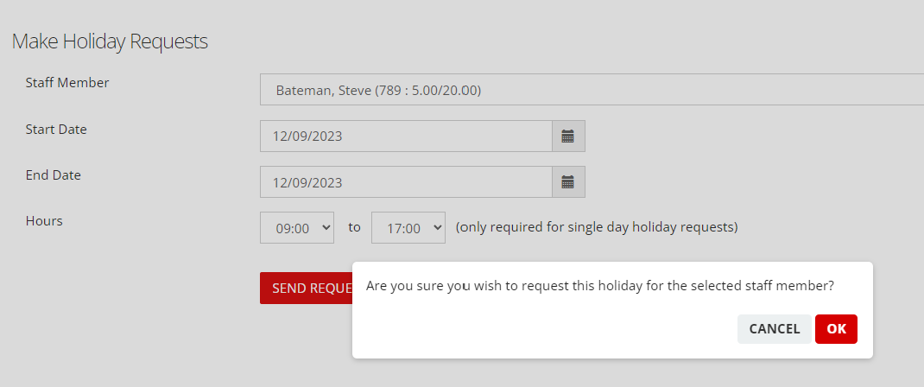
Your holiday request is now waiting approval by HO and status will change once approved
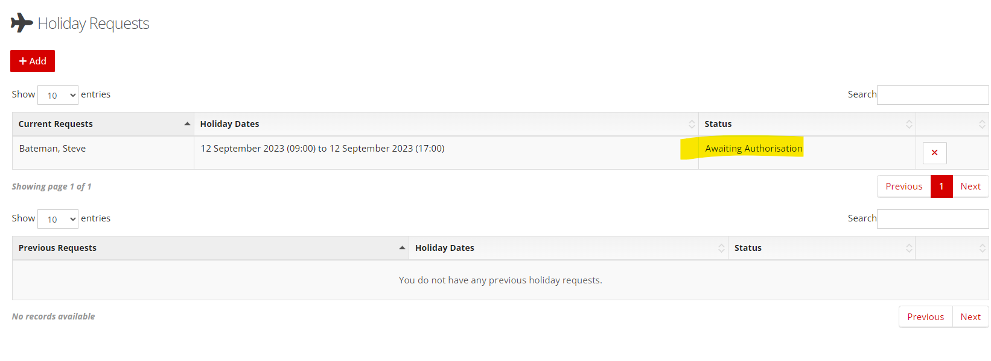
Once approved:
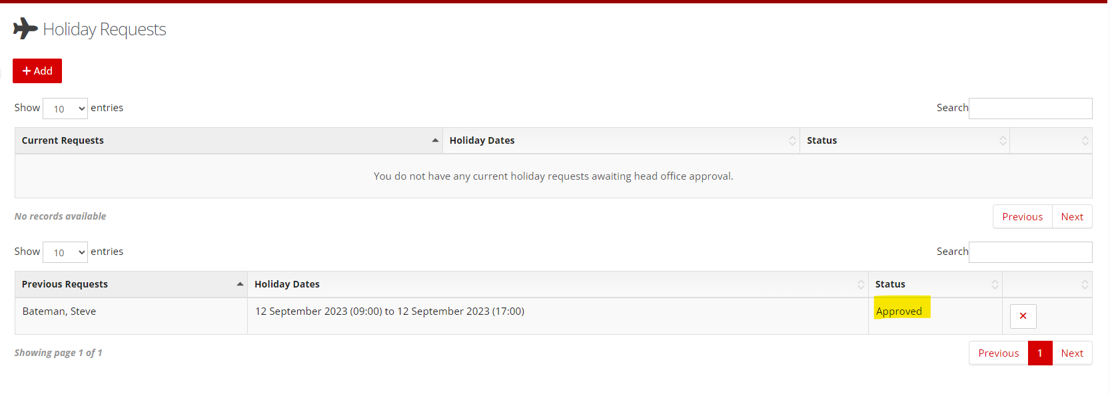

Running the timesheet/employment report :-
At the end of each week you should run the Timesheet/employment report and check it is correct, then close your Employment week to confirm you are happy that this report correctly reflects all the hours worked and any absence taken.
Click on Company >reports>new reports section>employment report:-
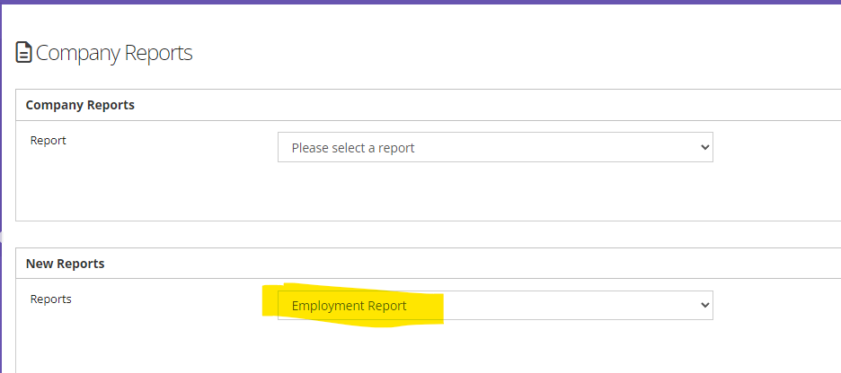
The report will download on screen and you can then export this into excel to save
Or from employment go to reports> and from the reports section choose Individual timesheet report :-
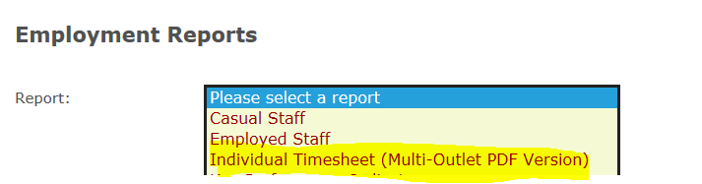

Complete each tab and select request report
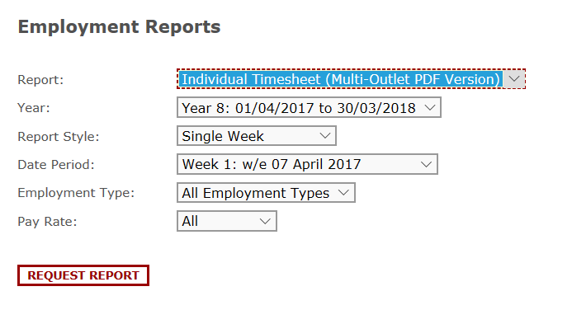
The report will be emailed to you usually in about 10 mins

